4.7 COLUMN DESIGN:
4.7.1 COLUMN:
It is a vertical structural member which transfers the compressive loads for, the ceiling. Roof, slab or beam, to the foundation.
It is constructed for, the materials like bricks, stones, timber, steel and other materials which have better compressive strength.
There are numerous types of columns available on basis of shape, type, loading type and slenderness ratio reinforcement.
Column type based on slenderness ratio:
- Short Column: if the ratio of effective length to the least lateral dimension is greater than 12 then it is called as long column.
- Long Column: if the ratio of effective length to the least lateral dimension is less than 12 then it is called as short column.
Column type based on type based on type of loading:
- Axially loaded column: The column which is subjected to loads acting along the longitudinal axis or centroid of the section is called as axially loaded column.
- Eccentrically loaded column: Loads which do not act on the longitudinal axis of the column is called as eccentrically loaded column.
Eccentrically loaded columns are then sub-divided into two types:
- Uni-axial column: if the eccentricity is with respect to either X-axis or Y-axis then the column is said to be under uni-axial loading.
- Bi-axial column: if the eccentricity is with respect to both X-axis and Y-axis then the column is said to be under bi-axial loading.

the types of columns used for column design are shown in the figure below.
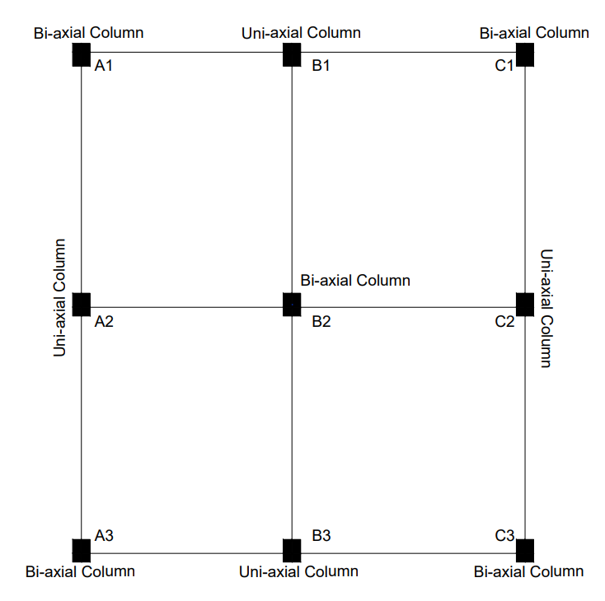
Figure 4.7: classification of column based on position and loading.
4.7.2 Code limitations:
The limitations and specifications for column design, given in IS-456-2000, page No.48 are
Column:
longitudinal reinforcement:
- The cross-sectional area of longitudinal reinforcement shall not be less than 0.8 percent nor more than 6 percent of the gross cross-sectional area of the column.

- In any column that has a larger cross-sectional area than that required to support the load, the minimum percentage of steel shall be based upon the area of concrete required to resist the direct stress and not upon the current area.
- The minimum number of longitudinal bars provided in to column shall be rectangular in four columns and sic in circular columns.
- The bars shall not be less than 12 mm in diameter.
- Spacing of longitudinal bars measured along the periphery of the column shall not exceed 300 mm.
- In case of pedestals in which the longitudinal reinforcement is not taken in account in calculations, rated strength longitudinal reinforcement not less as 0.15 percent of the cross-sectional area shall be provided.

Pitch and diameter of lateral ties:
- Pitch- The pitch of transverse reinforcement shall be not more than the least of the following distances:
- The least lateral dimension of the compression members,
- Sixteen times the smallest diameter of the longitudinal reinforcement bar to be tied, and
- 300 mm.
- Diameter – the diameter of the polygonal links side or ties shall be not less as one fourth of the largest longitudinal bar. And in no case less than 16 mm.

4.7.4 A1 column – storey-I (Bi-axial Bending):
Size of the column = 230 x 300 mm
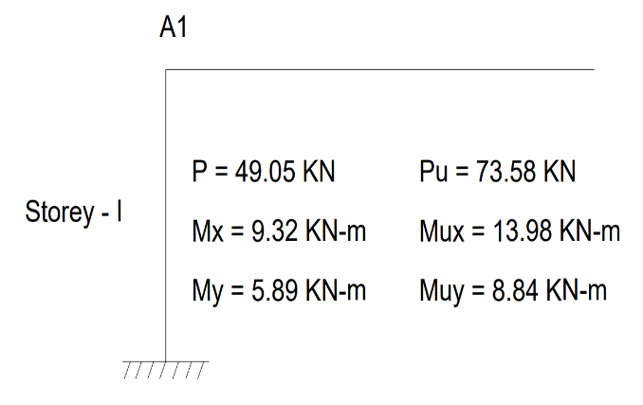
Concrete mix = M₂₀
Characteristics strength of reinforcement = 500N/mm²
Factor Load (P_{u}) = 73.58 KN
Factor moment acting parallel to the
large dimension, mix = 13.98 KN-m
Factor moment acting parallel to the Figure 4.9: Total Loads and moments on A1 column.
short dimension, mix = 8.84 KN-m
Reinforce is distributed equally on four side
Gross Area (A_{g}) = 230 × 300 = 69000 mm²
Required Minimum Steel: 0.008 × 69000 = 552 mm²
First, we assume a trial reinforcement area. Let's provide 4 bars of 16 mm diameter.
Area of Steel Provided (A_{sc}) = 4 × 201 = 804 mm²
Assuming % of steel P = 1.17 %
Area of Concrete (A_{c}): A_{g} – A_{sc} = 69000 – 804 = 68196 mm²

Assuming Effective Cover = 40mm
Reinforcement Ratio:
$$\frac{P}{f_{ck}}= \frac{1.17}{20}=0.058$$
Axial Load Ratio:
$$\frac{P_{u}}{f_{ck}.b.D}= \frac{73.58×{10}^{3}}{20 ×230×300}=0.053$$
Calculate Ultimate Axial Load Capacity
P_{uz} = 0.45f_{ck}A_{c} + 0.75f_{y}A_{sc}
P_{uz} = (0.45 × 20 × 68196) + (0.75 × 500 × 804)

P_{uz} = 915264N = 915.264KN
$\frac{P_{u}}{P_{uz}}= \frac{73.58}{915.264}$ = 0.080
According to IS 456 Table 10.2 (or SP-16 Chart 64), because 0.080 ≤ 0.2, the value of α_{n} = 1.0.
Determine Uniaxial Moment Capacities (M_{uxl}) & (M_{uyl})
Capacity about the Major Axis XX (M_{uxl})
Cover Ratio: $\frac{d^{'}}{D}$ = $\frac{40}{300}$ = 0.133
Referencing SP-16 Chart 48 (for Fe500, equal reinforcement on 4 sides, d'/D=0.133): Looking at the curve for $\frac{P}{f_{ck}}$ = 0.06 and $\frac{P_{u}}{f_{ck}bD^{2}}$ = 0.05, we read the moment parameter:
$$\frac{M_{uxl}}{f_{ck}bD^{2}} ≈0.070$$
M_{uxl} = 0.070 × 20 × 230 × 300² × 10⁻⁶
M_{uxl} = 28.98 KN-m
Capacity about the Minor Axis YY (M_{uyl})
Cover Ratio: $\frac{d^{'}}{b}$ = $\frac{40}{230}$ = 0.174
Referencing SP-16 Chart 48 (for Fe500, interpolating between, d'/D=0.15 and 0.20):
$$\frac{M_{uyl}}{f_{ck}Db^{2}} ≈ 0.064$$
M_{uyl} = 0.064 × 20 × 300 × 230² × 10⁻⁶
M_{uyl} = 20.31 KN-m
Check Biaxial Bending Interaction Equation
we apply Bresler's empirical formulation (IS 456 Clause 39.6) to ensure the combined stress is less than 1.0.
$${\left(\frac{M_{ux}}{M_{ux1}}\right)}^{α_{n}}+ {\left(\frac{M_{uy}}{M_{uy1}}\right)}^{α_{n}}≤1.0$$
$${\left(\frac{13.98}{28.98}\right)}^{1.0}+ {\left(\frac{8.84}{20.31}\right)}^{1.0}≤1.0$$
0.482 + 0.435 = 0.917
Final Verdict Because 0.917 ≤ 1.0, the design is SAFE.
The minimum practical reinforcement of 4 bars of 16 mm diameter (with 8 mm lateral ties at 200 mm c/c) is mathematically proven to handle your frame moments and axial loads under biaxial bending perfectly.

